Circuit Board Trivia Game

Set of 4 Lesson Plans
Made in Summer 2020
Circuit Board Trivia Game
Lesson 1: What Makes Good Trivia?
This project is designed to teach kids basic engineering and science concepts related to electrical circuits in a fun, hands-on activity where the kids will create and wire their own trivia games. While primarily a STEM project, the trivia board can also allow kids to explore whatever topics interest them and tap into their creative and artistic sides. This project can also be expanded in future iterations from individual boards to a community trivia board with interchangeable questions and answers.
Learning goals: Students will understand what makes a good trivia question, demonstrate proficient writing skills, and reflect on knowledge they find interesting.
Objectives: At the end of this lesson, students will be able to:
- List at least one recommendation for designing trivia
- Organize trivia questions based on answer type and category
- Identify a topic of interest to them
- Write their own trivia (6-10 questions) using the skills presented in the lesson
Materials:
- Paper and pencils
- Trivia “prizes” like candy or stickers
- Completed trivia game board (see instructions in lessons 3 & 4 for construction)
Time to Complete: ~30 minutes
Lesson Plan Outline:
- Play trivia game together
- Brainstorm trivia topic
- Learn: What makes good trivia?
- Write own trivia questions
- Class trivia challenge using kids’ questions
Prep Work: Build a sample trivia board to use in demonstrations (see Lessons 2, 3, & 4 for instructions).

Instructions:
Engage: Start by showing the kids a finished trivia game board. Explain that over the next few weeks, they will be learning how to design and build their own. Have kids gather around the board and play the trivia game together so they can see how the game works. Offer prizes like candy or stickers when kids guess correctly.

Explore: Explain that the first step in making their own trivia games is writing some trivia. Ask kids to think of topics they know a lot about. Possible questions to ask are:
- What topics or subjects seem cool to you?
- What activities are you good at?
- What do you like to read about? Watch movies about?
- What’s your favorite subject in school?
- What’s something you wished you could learn more about?
Have the kids decide on a topic they’d like to explore more for their trivia.

Explain: Walk the kids through the following tips for writing challenging but fun trivia. Use the trivia listed at the end of this lesson plan for examples.
Theme: Give the trivia a theme (sports, movies, Harry Potter, space, animals, etc.). Picking a theme will help the kids narrow their focus in coming up with questions and will help with decorating the board.
Variety: Vary the types of questions (What is the name? When? Where? How many? How old?). Instead of six questions asking, “What is the name of…?”, choose questions that ask for a variety of answer types (people, places, things, numbers, etc.).
- Who is the American gymnast who won four gold medals in the 2016 Olympics? (Simone Biles) answer is a person
- How many points does a football team earn with a touchdown? (6 points) answer is a number
- What sport did Michael Jordan play? (basketball) answer is a thing
Multiple choices: Write at least two questions that have answers of the same type (names, dates, numbers, places, etc.) to add a challenge to the trivia.
- Which planet is named after the Roman God of the Sea? (Neptune)
- Which planet is the largest in the solar system? (Jupiter)
- Both answers are planets, so the player must choose between the two when answering (if there was only one planet question, it would be obvious from the word bank what the answer was).
Specific: Choose questions that have a specific answer, so that no answers are too similar to each other. Aim for answers to be one or two words long.
- Who was the first American woman in space? (Sally Ride) VS. Who was Sally Ride? (too many possible answers, answer will likely be longer than two words)
- Where does Harry Potter go to school? (Hogwarts) VS. What does Harry Potter learn at Hogwarts? (too many possible answers, answer could be “magic” but a better question could be written)
Difficulty level: Know your player audience and choose questions of a reasonable level, not too easy but not too hard.
- Which part of a plant uses sunlight to make food? (leaf, knowledge appropriate for 3rd-5th grade level) VS. What is the scientific name for a Venus flytrap? (Dionaea muscipula, too difficult an answer)
Good research: Double-check your answers to make sure they are accurate. Use the resources at hand (nonfiction books, Internet searches, etc.) to explore different topics.

Extend: Give kids sheets of paper and writing utensils. Ask them to number their paper from 1-6. Have them spend 10-15 minutes coming up with a trivia theme and questions/answers. Break down the process by asking them to write two questions that ask for the name of something/someone, two questions with numbers as the answer, and two questions about places, for example. Pause for 2-3 minutes between each question type to give kids time to write the appropriate questions. For simplicity, the game boards will include only six questions/answers, but encourage the kids to write more than six if they want.
- NOTE: If you have access to computers, help the students research answers online with a Google search. If no computer access, encourage students to pick topics that they already know a lot about or use books to research topics.

Evaluate: Have the kids share some of their trivia questions with each other and quiz each other. Possible set-ups are below:
- Have each kid offer one question they wrote and ask class to guess the answer
- Compile all questions written and hold a whole-class trivia competition
- Choose one or two students’ trivia questions to play with the whole class. Have that student stand at the front as the “trivia master/game show host” who will read out each question. Either allow student players to raise hands to answer or invite two students to front of room to “battle” for the answer. Place an object such as a stool or book on a table between the dueling students and have them hit the object as a buzzer before answering the question (if dueling, split class into two teams and send one member of each team for each question).
- Split the class in half and assign one half as the “trivia masters” and one half as the players. Pair up one trivia master with one player and scatter the pairs around the room. For a set amount of time (~3 minutes?), have trivia masters test the players on the masters’ trivia questions. Then switch roles or have the players rotate to another trivia master and repeat.

Ask the students to offer each other feedback on their questions.
- Were the questions too easy? Too hard?
- Were the answers specific to each question (not too vague)?
- Was there a theme to the questions?
- Was the theme too vague? Too specific?
Have students write their names on their trivia papers, and collect all papers to store for the next lessons.

Sample Trivia Questions:
Set 1: All about me
- My favorite food is ______.
- I am ____ years old.
- I have _____ siblings.
- One of my hobbies is _____.
- I like to learn about _______.
- When I grow up, I want to be a ______.
- A food I know how to make is _______.
- My favorite subject in school is ______.
- I have lost ____ teeth.
- I’m really good at ______.
Set 2: Sports
- Michael Phelps is famous for winning record gold medals in which sport? (swimming)
- Who is the American gymnast who won four gold medals in the 2016 Olympics? (Simone Biles)
- How many points does a football team earn with a touchdown? (6 points)
- How many points does a player get for making a basket from the free throw line? (1 point)
- What sport did Michael Jordan play? (basketball)
- Who is the American female tennis player who holds the most Grand Slam titles of any current player? (Serena Williams)
- Which NFL team won the 2020 Super Bowl? (Kansas City Chiefs)
- Who was the first African American to play in Major League Baseball? (Jackie Robinson)
- What is the name of the MLB team in St. Louis? (St. Louis Cardinals)
- Which sport is not an Olympic event? (American football)
Set 3: Space
- What is the name of the largest dwarf planet in our solar system? (Pluto)
- Which planet is the largest in the solar system? (Jupiter)
- What is the name of the galaxy that contains our solar system? (Milky Way)
- What is the name for an exploding star? (Supernova)
- Which NASA mission was the first to land people on the moon? (Apollo 11)
- The movie Hidden Figures tells the story of which African American woman who worked as an important NASA scientist? (Katherine Johnson)
- Who was the first American woman in space? (Sally Ride)
- Which planet is named after the Roman God of the Sea? (Neptune)
- What is the name of the NASA rover currently exploring Mars? (Curiosity)
- What is another name for a “shooting star”? (Meteor)
Circuit Board Trivia Game
Lesson 2: Designing the Game
Learning goals: Students will embrace their creativity and demonstrate effective spatial design skills.
Objectives: At the end of this lesson, students will be able to:
- Design a trivia game board based on a chosen theme
- Generate a creative game title based on a chosen theme
- Organize trivia questions and answers into a randomized pattern on the board
- Draw a “blueprint” of the connections between questions and answers for future wiring
Materials:
- Cardboard sheet, approx. 10” x 12”
- Paper and writing utensils for writing questions/answers and making “blueprints”
- Art supplies (markers, crayons, glue, scissors, construction paper, etc.)
- Metal brads (12 per child)
Time to complete: ~30 minutes
Lesson Plan Outline:
- Look at finished board for decorating ideas
- Learn: What design aspects do we need to include on the boards?
- Design/decorate game boards
- Draw wiring “blueprint”

Instructions:
Engage/explore: Begin by explaining that today’s goal is to decorate the game boards. Ask the students to recall the trivia questions they came up with in the last lesson. Redistribute their trivia papers so they can review the questions they wrote. Now ask the students to gather around the sample trivia board. Ask the students what design elements they notice.
- Is there a title?
- Can you easily identify the theme of the trivia?
- How are the questions and answers organized on the board? (two columns, with questions on left and answers on right, questions and answers are mixed up/not in order)
- How is the LED integrated into the design?
- What aspects make the game fun to look at?
Explain: After exploring the sample board, ask the students to revisit their written questions and brainstorm a fun title for their games, based on the theme they’ve chosen. Explain that the basic set-up of the trivia board will contain 1) a fun title related to the theme, 2) a column of questions and a column of answers, 3) a spot for the LED, and 4) decorations.
Extend: Pass out cardboard for each student and set up art supplies for them to use for decorating. Older students can freely work on their boards, but if more structure is needed/helpful (especially with younger kids), use the following outline:
- Begin with rewriting the questions and answers on slips of paper that will fit appropriately on the board (Words should be big enough to read easily, but the slips should not take up the entire board space). Ask the kids to focus on their handwriting.
- Next, place the slips on the board and map out where the question and answer columns will go. Be sure to leave space for a title. Don’t glue down the slips yet.
- Create the “background” of the game using construction paper, crayons, markers, etc. What does the student want people to see behind the questions and answers? Is there a scene he/she wants to illustrate that goes with the theme? Where will the LED go?
  - LED placement ideas:
    - Christmas theme: LED is Rudolph’s nose or star at the top of the tree
    - Sports theme: LED is the ball or part of a scoreboard
    - Space theme: LED is a star or the “red spot” on Jupiter
    - Harry Potter theme: LED is Harry’s scar or the tip of his wand
  - LED doesn’t have to be incorporated into the theme and can just be placed in a suitable spot on the board, but encourage the kids to brainstorm creative ways to showcase the LED.
  - *The LED will be placed on the board in later lessons—in this lesson, students just need to pick a spot for the LED to go.
- Draw the question/answer wiring connections. On a sheet of paper, have the kids write the numbers of the questions on the left side of the page and the numbers of the answers (in a different order) on the right side of the page (For example, a student may write “1, 3, 4, 2, 5, 6” on the left side and “2, 5, 6, 4, 1, 3” on the right). Students should use the numbers on their original trivia papers from Lesson 1. Now have them draw a line connecting each question to its correct answer. This drawing will serve as a “blueprint” for the wiring in lesson 4. Be sure the students write their names on their blueprints.
- Paste the questions and answers on top of the background drawings on the board, following the “blueprint” they just drew and leaving space for the title. For example, if a student used the number orders listed above, s/he would paste Question 1, then Question 3 below it, then Question 4, etc. on the left side of the board and Answer 2, then Answer 5 below it, then Answer 6, etc. on the right side of the board.
- Add the title.
- Use pencils or metal brads to poke holes in the board next to each question and answer. Insert a metal brad in each hole.
- Flip board over to the back and use the “blueprint” to draw lines connecting the questions and answers.
  - NOTE: On the back of the board, the question column will now be on the right and the answers column will be on the left. Have volunteers help each student draw the connections accurately so that the questions and answers are matched. If it helps, rewrite the question and answer numbers from the blueprint onto the back of the board in the appropriate order so kids can easily see where to draw the connecting lines. (See blueprint and board below)
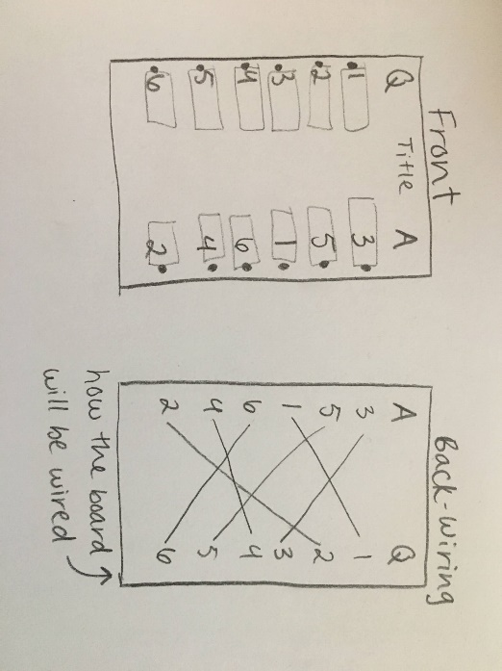
Evaluate: Invite the kids to give each other inspiration for how to decorate their boards. Offer words of affirmation as they work!
Ask the kids to write their names on the back of their trivia boards and collect the boards at the end of the lesson. They will be used again in Lesson 4.
Circuit Board Trivia Game
Lesson 3: Wiring the Game (Part I)
Learning goals: Students will understand the basics of electrical flow in a circuit.
Objectives: At the end of this lesson, students will be able to:
- Differentiate between open and closed circuits
- Identify the properties of good conductors
- Explain the function of a battery in an electrical circuit
- Assemble a basic electrical circuit
Materials:
- Pre-cut strips of aluminum foil, between 9 and 18 inches long (three per child)
- LED light bulbs
- AA alkaline batteries (1.5V each, two per child)
- 100 ohm resistor (optional but recommended)
- Thin rubber bands
- Masking tape
- Electrical tape
- Paper clips (two per child)
Time to Complete: ~45 minutes
Lesson Plan Outline:
- Electrical circuit demonstration
- “Circuit” group exercises
- Learn: What is a circuit? What are its components?
- Build circuits
Prep Work: Tear off 1.5-2 inches of aluminum foil and fold several times lengthwise to form narrow “wires.” Trim wires to be about 9 inches long. Each child will need three wires. Follow steps 1-9 in the “Extend” section of the instructions below to create a sample circuit to use as demonstration at beginning of lesson.

Instructions:
Engage: Begin by saying that today’s focus for the trivia project is creating the electrical circuit that powers the game. Ask the students if they can give some examples of things powered by electricity (lights, cars, computers, etc.). Flip a light switch on and off and ask students if they can explain why the light goes on and off based on the switch. They may not be able to answer, but encourage them to brainstorm what’s happening behind the scenes when the light switch is flipped one way and then the other way.
Introduce the electrical circuit by showing the sample circuit built beforehand. Explain that behind everything operated by electricity uses a “circuit” that allows energy to flow. Show the students that the LED lights up when the paper clip probes touch, or let one student hold the two paper clips together to turn the LED on.
- What about the circuit is changing to cause the light to turn on or off? (When the probes touch, the light turns on. When the probes don’t touch, the light remains off.)
Explain that today the students will explore the basics of circuits and build their own.
Explore/explain: Ask the students to stand in a circle and hold hands. Choose one person to be the “LED” and one person to be the “battery.” The “battery” starts a squeezing chain by squeezing the hand of the child to the right. Once a child feels the squeeze, s/he passes it on by squeezing the hand of the next person in the circle. Have the “LED” make a noise when s/he feels the squeeze. When the squeezing chain reaches the battery again, have the kids let go.
Ask the kids what role the battery and LED played in this demonstration
- Why do you think we needed the battery? What did the battery do in the chain? (The battery started the chain and gave the squeezing chain a power source)
- What did the LED do in the chain? (The LED changed its behavior based on whether the squeeze reached him/her)
- Why would we want to add a 100 ohm resistor between the LED and the battery? How can we do that?
Help them draw the connection between this exercise and what’s happening in the circuit.
Repeat the squeezing chain exercise but have two kids positioned between the “battery” and “LED” let go of each other’s hands before the chain starts. Now the squeezing chain will not reach the “LED” and the “LED” will not be able to make any noise. Ask the kids what has changed in this scenario due to disconnecting two hands in the circuit. Now repeat by having the two kids hold hands again. Now the circuit is closed and fully connected, so the “LED” makes a noise and the squeezing chain goes all the way around the circle to return to the “battery.” Explain that a closed circuit is fully connected and allows the electrons from the battery to flow to the LED and back to the battery. Explain that an open circuit, like the example with the disconnected hands, prevents the electrons from flowing between the LED and battery, so the LED can’t light up.
In a third version of this exercise, ask students to hold onto an object between each student, so that their hands are on the object rather than the hand of the person next to them (for example, have students each hold an end of a stick or book). Have them repeat the squeezing chain and ask them what they experience.
- Are they able to feel the squeeze now that they are holding an object instead of a hand?
- What happens to the LED? (The chain should not be able to move throughout the circle, so the LED should stay quiet. Only the battery should be squeezing.)
- How has holding an object affected the squeezing chain’s ability to flow through the circle? (squeeze chain is broken)
Explain the concept of conductors and insulators. Conductors are materials that allow electrons to flow through them, whereas insulators block electron movement. Ask the students to identify which exercise represented conductors (holding hands directly) and which represented insulators (holding object between hands). Draw the connection that the materials used in a circuit therefore affect the circuit’s function. Conductors are typically metal, whereas common insulators are made of glass, plastic, or wood. Ask the students if they think the circuit would work using different materials. Examples are below:
- What if the circuit was made of string with button probes? (No because there is no conductor material)
- What if the circuit used wire and button probes? (No, electrons could flow through wire but not through the buttons--insulators)
- What if the circuit used wire and paper clip probes? (Yes, has conducting material)
Now have students return to their seats and bring the sample circuit back out. Ask students to identify whether the circuit is open or closed when you connect or disconnect the paper clip probes. Be sure they can identify the difference between open/closed circuits.
*This is a possible stopping point if time is running out. You can continue with the steps below in the next session if needed.
Extend: Have the students apply their new knowledge to building their own circuits. The steps are outlined below:
- Place two batteries in sequence so that the positive end of one battery is touching the negative end of the other battery.
- Wrap a rubber band lengthwise around the two batteries (younger children will need assistance) and securely tape the two batteries together at the point where the two ends touch. The rubber band should be underneath the masking tape (see below).

- Take one piece of foil “wire” and slip it underneath the rubber band so it touches one terminal of the battery complex and secure with electrical or masking tape. Repeat with another wire on the opposite terminal (can be seen in image above).
- For the wire attached to the negative terminal of the battery complex (there should be a minus symbol on that end of the battery), wrap the loose end of the wire around the cathode (shorter leg) of the LED light. Secure the wire-LED connection with a small piece of masking tape. *NOTE: this wire can be a shorter length, approx. 6-8 inches long
- For the wire attached to the positive terminal of the battery complex, attach a paper clip to the loose end of the wire (slip the wire end between the metal of the paper clip) and secure with masking tape. This forms one of the playing probes.
- Wrap one end of a third wire around the anode (longer leg) of the LED light and secure with masking tape. Attach a paper clip to the other end of this third wire to form the second playing probe.
- Wrap a piece of electrical tape around the two wire-LED connections to prevent the foil pieces on either leg of the LED from touching. (If the foil touches, the circuit could bypass the LED and the LED won’t light up.)
- Test the circuit by touching the paper clip probes together—the LED should light up!
- Be sure that the paper clip probes can reach all brads on the board.

The completed circuit should look like this:
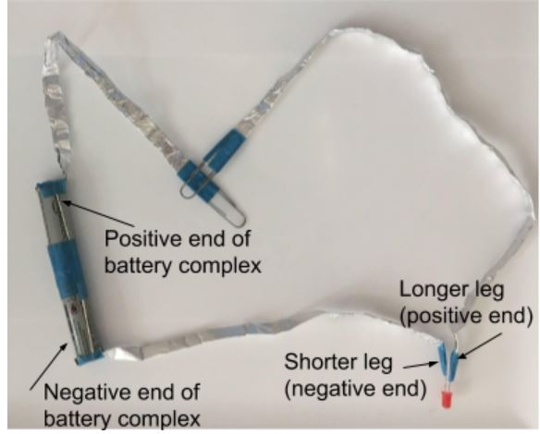
Troubleshooting Guide:
If the LED is not lighting up when the paper clips touch, here are the potential issues and how to resolve them:
- Batteries aren’t lined up correctly—be sure the positive end of one is touching the negative end of the other
- The legs of the LED are attached to the wrong wires—be sure the shorter leg is attached to the wire that connects to the battery complex
- The wires on the LED legs are touching without insulation—add electrical tape around the wires so that no foil will accidentally touch the other foil pieces
- An LED leg isn’t fully touching a wire—be sure that the ends of the wires connecting to the LED legs are wrapped tightly enough to allow only a small hole for the LED leg to fit in securely
- The LED is burned out—try a different LED
- The batteries are dead—replace with fresh batteries
This wiring can be tricky, so be patient and help the kids resolve any issues calmly.

Circuit Board Trivia Game
Lesson 4: Wiring the Game (Part II)
Learning goals: Students will understand electrical wiring in the context of their trivia games.
Objectives: At the end of this lesson, students will be able to:
- Recall the difference between open and closed circuits
- Identify if a circuit is open or closed
- Apply their knowledge of circuits to troubleshoot issues if trivia game malfunctions
Materials:
- Game boards designed in Lesson 2
- Electrical circuits built in Lesson 3
- Strips of aluminum foil, between 9 and 12 inches long (6 per child)
- Masking tape (electrical tape works too)
Time to Complete: ~30 minutes
Lesson Plan Outline:
- Electrical circuit review
- Wire the boards
- Play the trivia games!
Prep Work: Tear off approx. 1-2 inches of aluminum foil and fold several times length wise to create narrow “wire” strips that will span from question brads to answer brads, approx. 9 inches long. Make enough wires for each question/answer pair on the trivia board.

Instructions:
Engage: Begin by reviewing what you did in lesson 3: learning about the electrical circuit that will power the game board. Ask them to recall:
- What did we do to turn the LED on? (touch the paper clip probes together)
- What do you call the circuit when the LED is on and the probes are touching? (closed circuit)
- What do you call the circuit when the LED is off and probes are not touching? (open circuit)
Then direct their attention to their game boards. Ask the students how they can combine their trivia boards with the electrical circuits they built to create an interactive game (need to wire question-answer connections on board into the circuit already built to make a closed circuit). Explain that today you will wire the board so that connecting each question to its correct answer will cause the LED to light up.
Explore/explain:
- What kind of circuit do we need for the LED to light up? (closed circuit)
- If we want to make a closed circuit, how should we wire the board so that the LED lights up when you choose the right answer? (have wires connecting the question to answer)
- What kind of material should we use to connect the questions and answers? (conductors – something metal like aluminum foil)
Extend: Next, walk the students through the following steps to help them wire their boards:
- Flip board over to back, where you can see the hand-drawn lines connecting questions to answers. Choose one connection to begin wiring.
- Fold one prong of the question brad down to the board (the two prongs should form a 90° angle) and place a strip of aluminum foil “wire” between the prongs of the brad (as shown below). Fold the upright prong of the brad over the foil to secure it in place.
- Secure the other end of the wire between the prongs of the answer brad, with the wire following the line drawn on the board.
- Cover the entire wire length with masking tape so that no foil or brad prong is exposed (Electrical tape also works, as shown below, but may not stick as well over time).
- Repeat steps 2-4 for each question-answer connection, using tape to cover them one at a time to prevent creation of multiple circuit paths.
- Attach the battery complex to the back of the board with heavy duty tape such as duct tape.
  - NOTE: Be sure to place the pack so that both paper clip probes can reach all the brads on the board (one probe for the question brads, one for the answer brads).
- If the students choose to incorporate the LED into their board design, you will need to slide the LED out from the wires connecting it to the battery and paper clip probe to situate it correctly on the front of the game board. Poke a hole in the board and insert the LED. Then reattach the LED legs to their respective wires (Remember: short leg to battery, long leg to paper clip probe).
- The wiring is now done and should look like the image below:
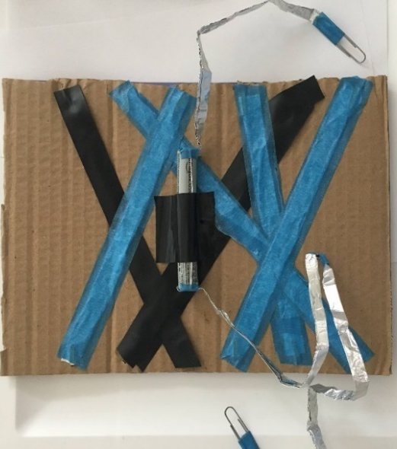
- Test the game! The LED should now light up when students match the questions to their correct answers.
  - NOTE: If LED does not immediately light up for correct answer, try moving the paper clip to different spots on the brad (connection can be spotty).
Invite the students to problem-solve any troubleshooting issues that arise. If the LED lights up for the wrong answer, what wiring issue might be responsible? (incorrect connections on back of board) If the LED doesn’t light up at all, what may have happened? (LED is burned out; battery is connected to wrong leg of LED; battery is dead; open circuit)
Have the students swap trivia boards to test each other’s knowledge. Maybe hold a trivia battle to see who can get the most questions right!

*A note on LEDs: The LEDs may burn out quickly without a resistor in the circuit, so tell the kids not to keep the LEDs lit up all the time. Certain LED colors (blue, purple, white) require a higher voltage (between 3 and 3.4V), so these colors may not light up as brightly as lower-voltage LED colors (green, yellow, orange, red).
*Store the game boards carefully. The foil probes are conductors and if they touch other metal objects, the circuit could overpower the battery and cause overheating or LED burnout. Don’t store multiple boards on top of each other, and once the kids are done playing, you may want to disconnect the battery circuit from the game board.

Future project ideas:
- Have kids design a large-scale community trivia board where they can swap out the questions and answers each week
- Create “All About Me” boards so the kids can get to know each other better
- Make trivia boards based on what the kids have learned from other learning modules (such as the other 2020 SSLP lesson plans!)

